**Creation Of CI/CD Pipeline using GitHUb and Testing**

**Code Written :** In Yaml file to print Hello World

**Tool Used :** Github for creation of CI/CD pipeline and for

Testing

**Status :** Success

**Prerequisites:**

1. Need a GitHub account
2. Code written in Yaml File

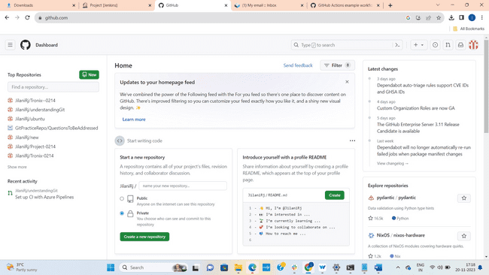



Open GitHub.com and sign in with Email and Password

Click on + to create a new repository.

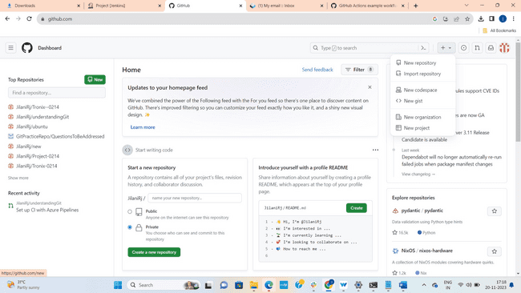



Click on New repository.

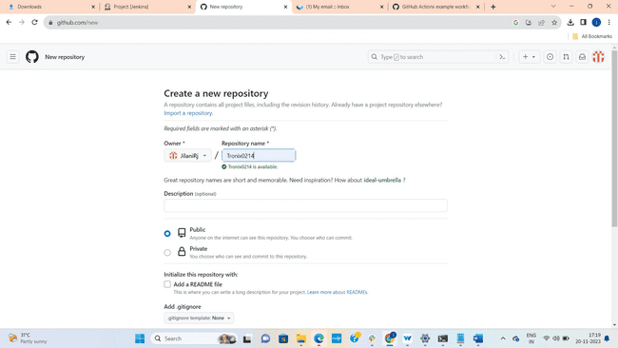



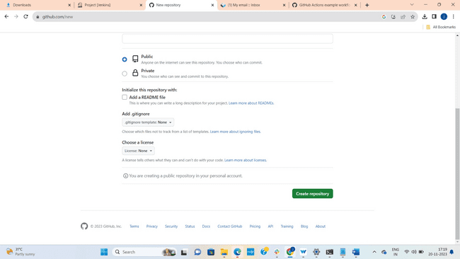



Give Repository Name and click on Create Repository.

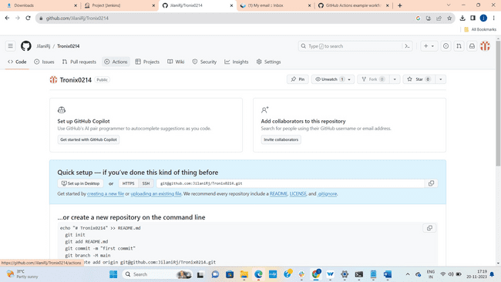



Goto Actions and click on actions

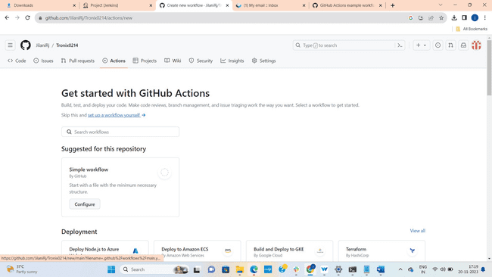



Now Click on Setup Workflow.

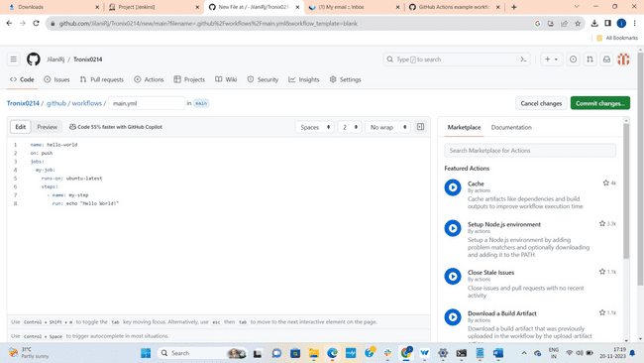



Write the code(here code is taken from google it is simple yaml file to print hello world) and click on commit changes.

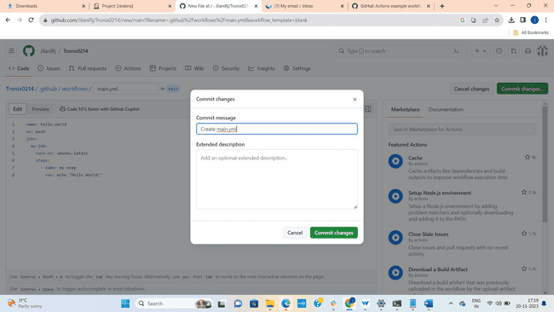



Give Commit Message and click on commit changes.

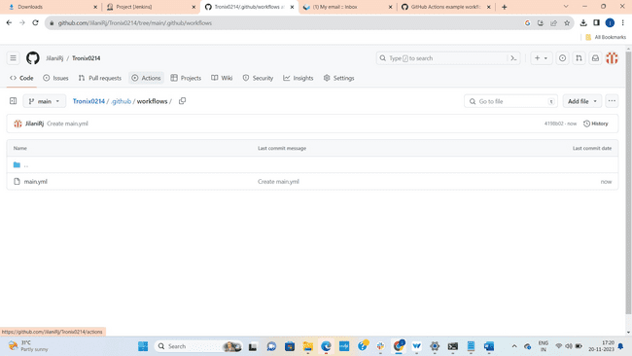



After clicking on commit changes you will redirected to this page. Click on Actions

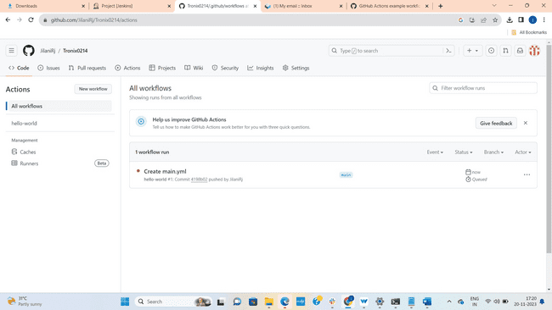

You can see here workflow is creating.

Click on Create main.yml

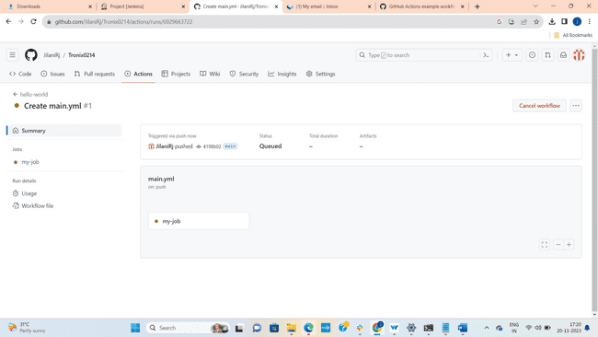



My job is creating here.

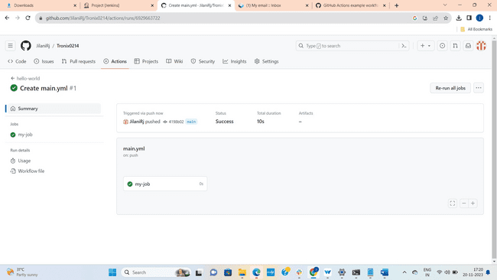



My job is created Click on My job

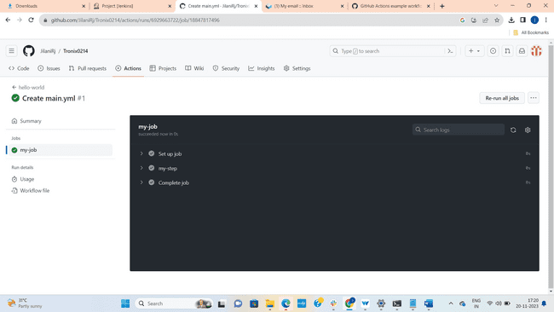



You will redirected to this page. Click on my step

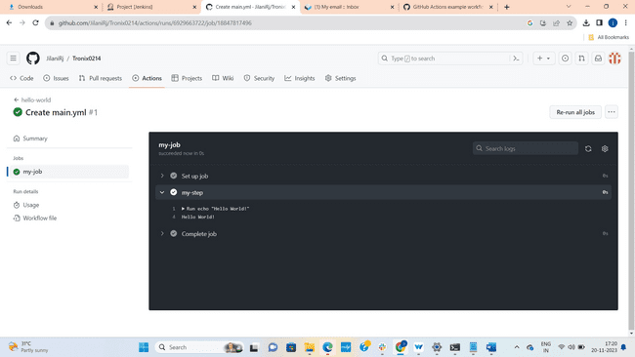



Here we can see Run Echo “Hello World”

And output also as Hello World

**Note :**  In the previous example we got error because of the code which we have written.